40.23: 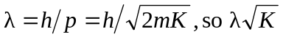is constant
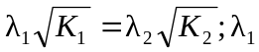 and 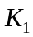are for 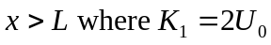 and 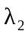 and 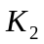 are for 